**Jahangirnagar University**

**Department of Computer Science & Engineering**



**Course Code**: CSE-402

**Course Title**: Computer Networking Laboratory

**Submitted by**:

**Name**: Md Shamim Imtiaz

**Roll No**: 47

**Date of Submission**: 24th October, 2019

**Experiment No: 06**

**Experiment Name:** IP Telephony

**Objective:**

We will simulate an IP telephony network with one switch connected with 8 IP telephone and a router to rout the packet transfer among the telephone via a switch.

**Description:**

IP telephony (Internet Protocol telephony) is a general term for the technologies that use the Internet Protocol's packet-switched connections to exchange voice, fax, and other forms of information that have traditionally been carried over the dedicated circuit-switched connections of the public switched telephone network (PSTN). Using the Internet, calls travel as packets of data on shared lines, avoiding the tolls of the PSTN. The challenge in IP telephony is to deliver the voice, fax, or video packets in a dependable flow to the user. Much of IP telephony focuses on that challenge.

**Simulation:**

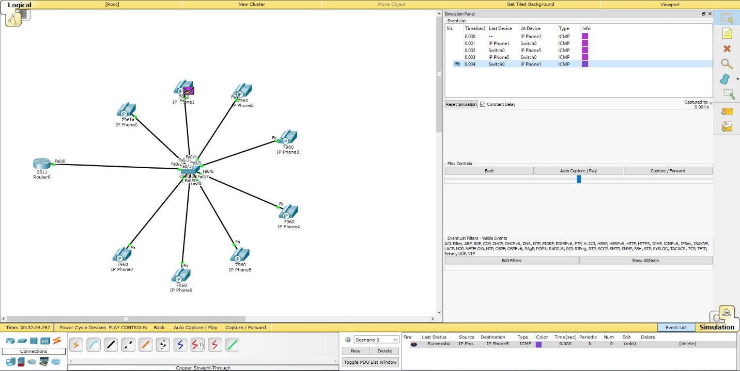

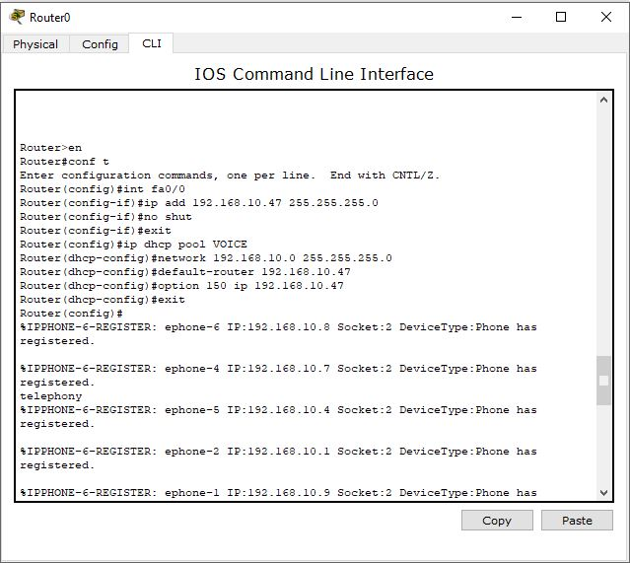 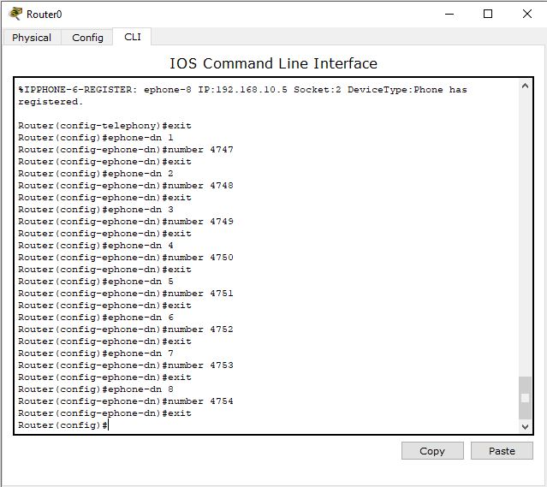

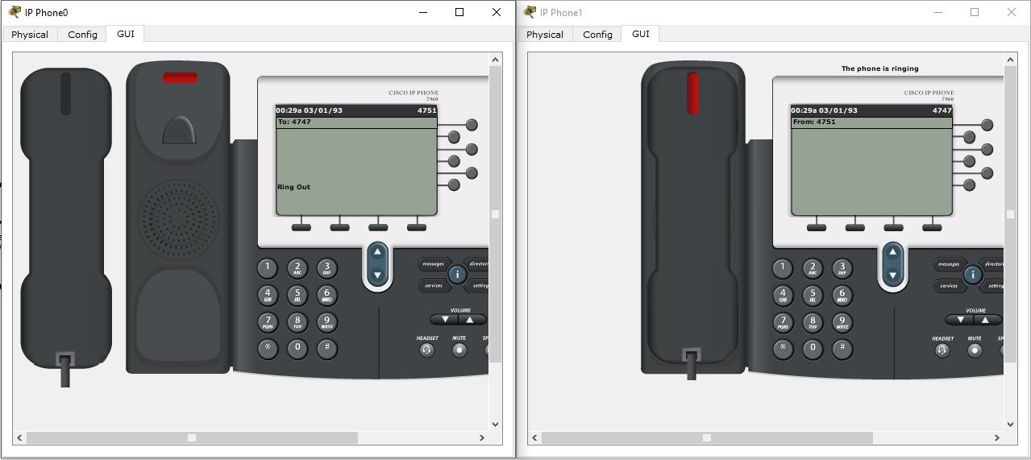

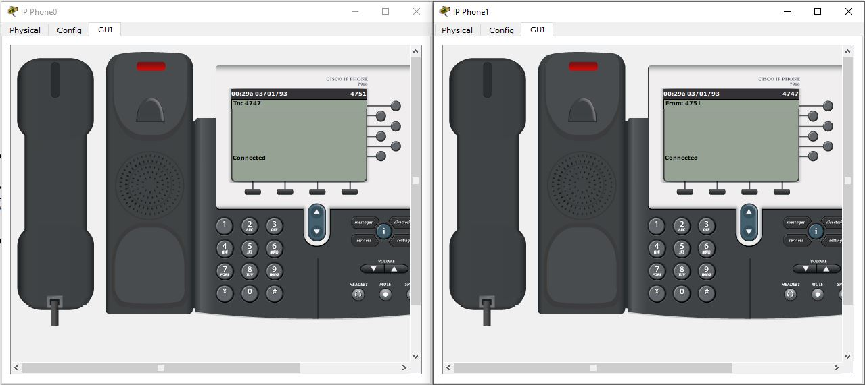

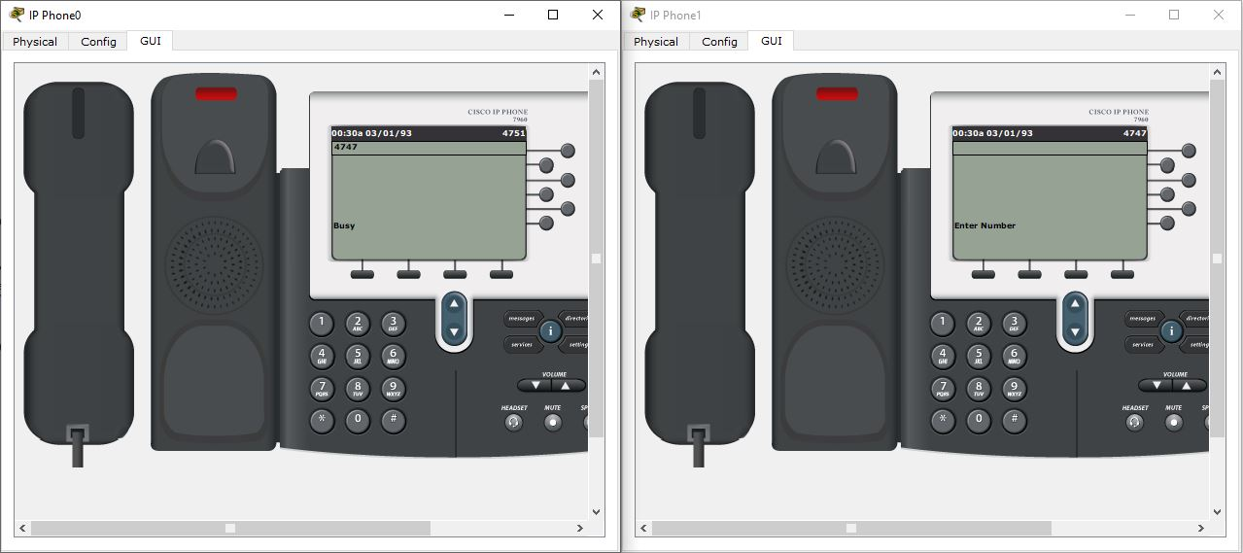

**Discussion:**

We can clearly observe that providing different ip to the telephones it is possible to transfer packet among them and construct a communication among them. So the experiment is valid.